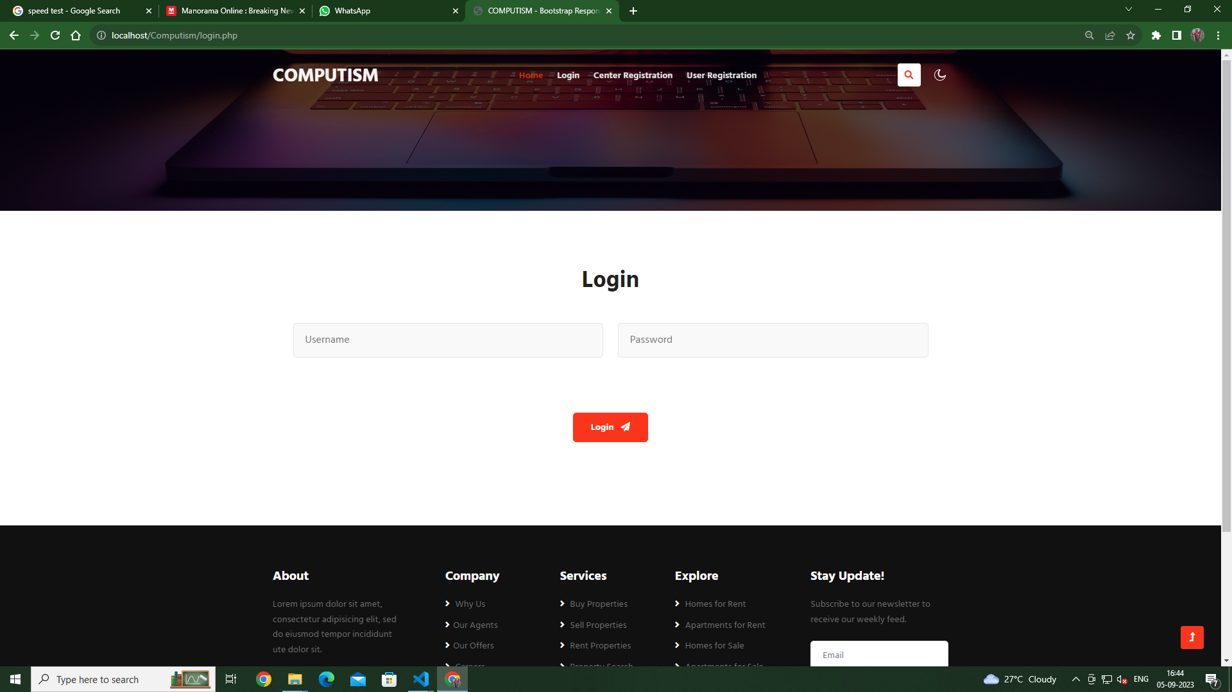

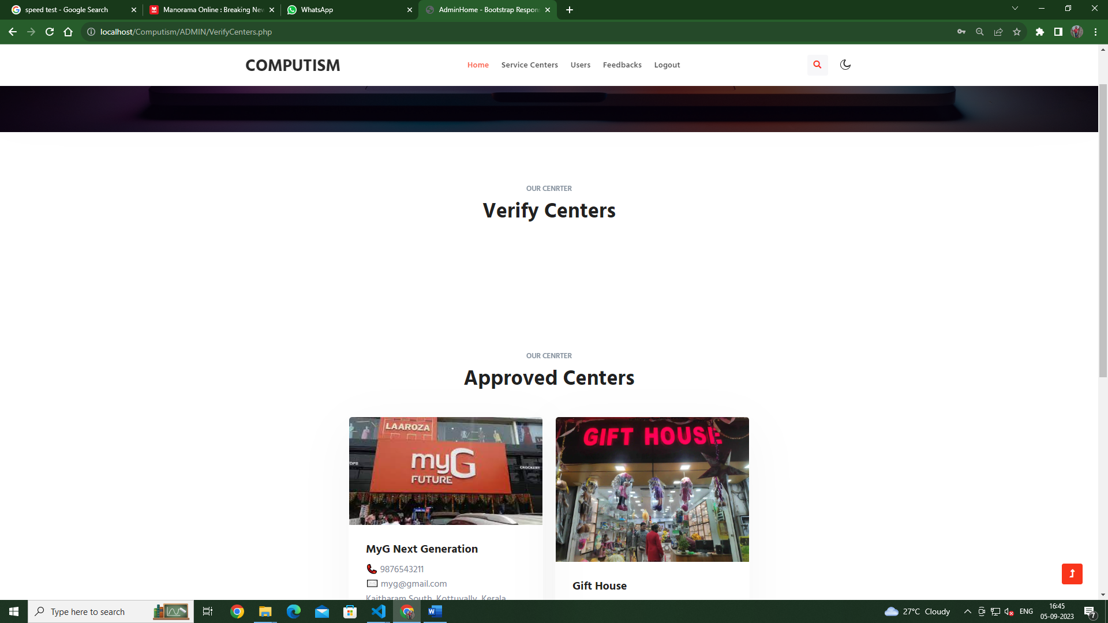

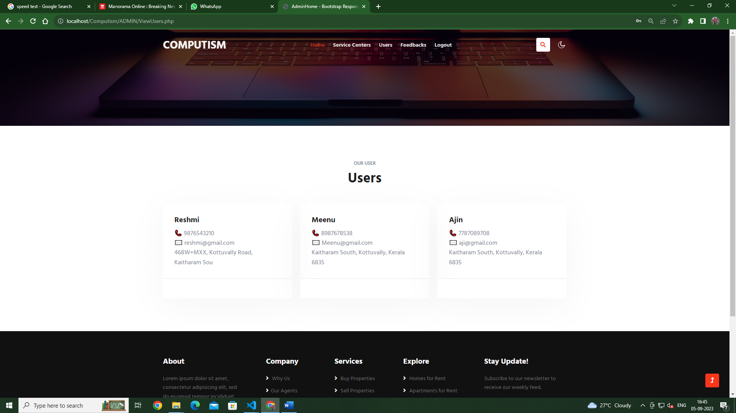

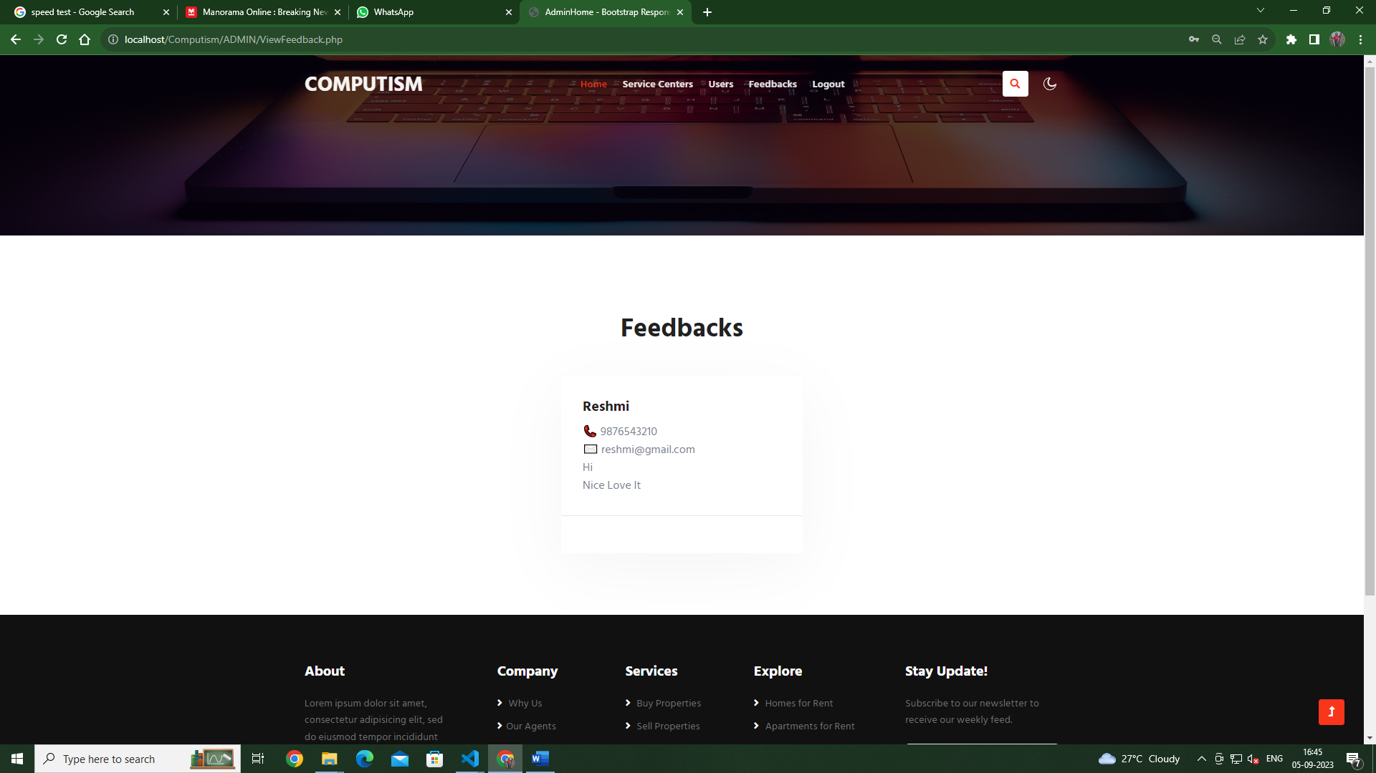

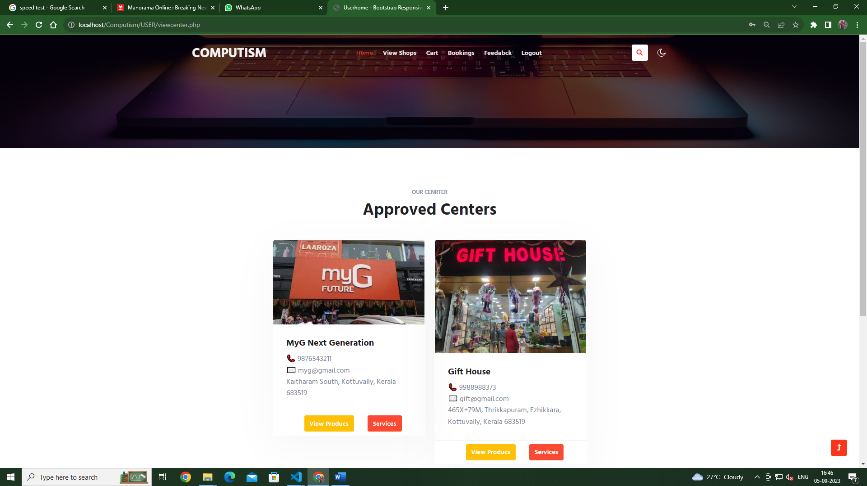

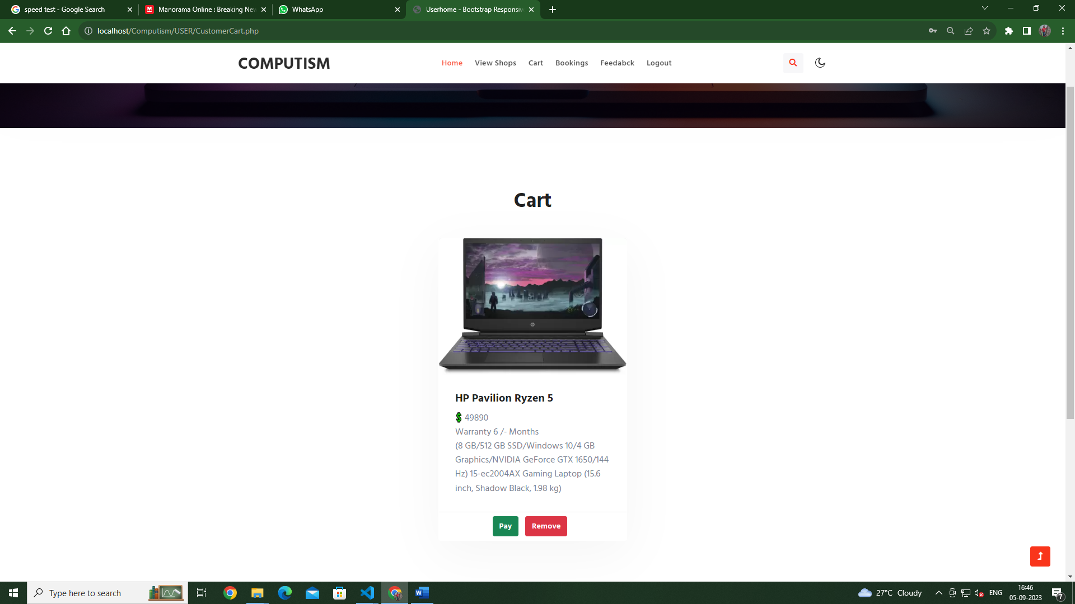

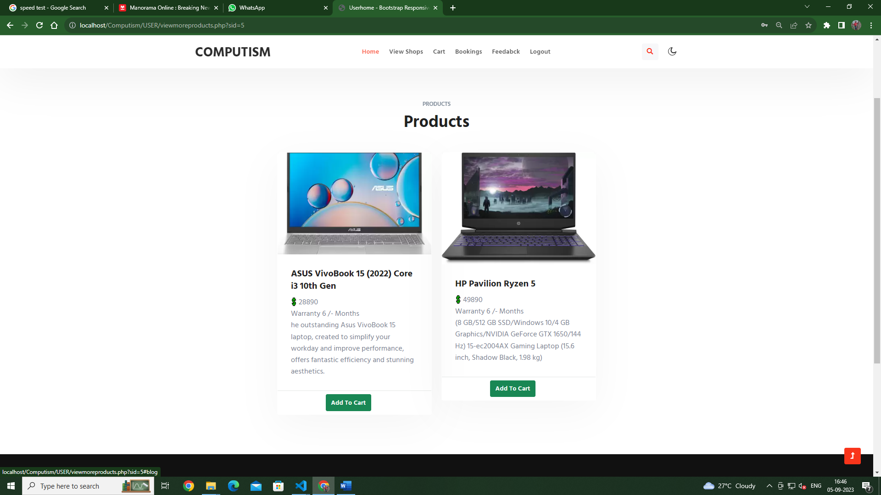

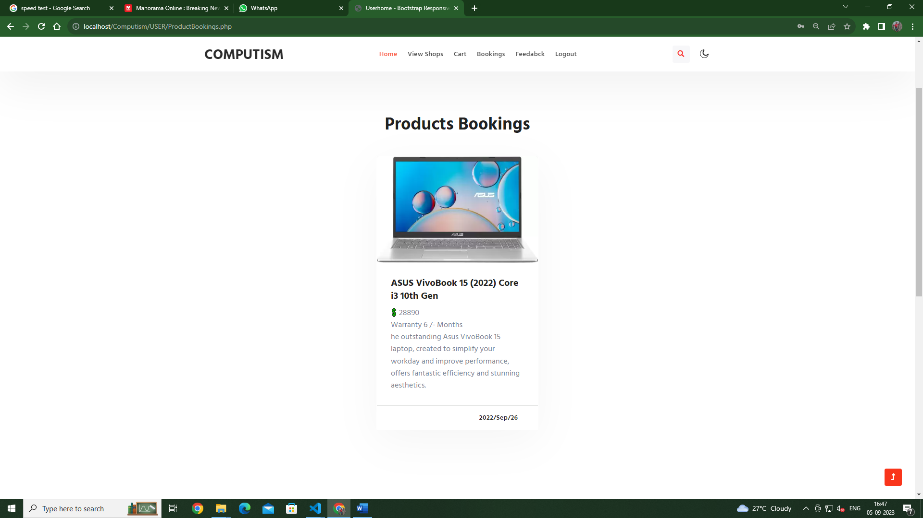

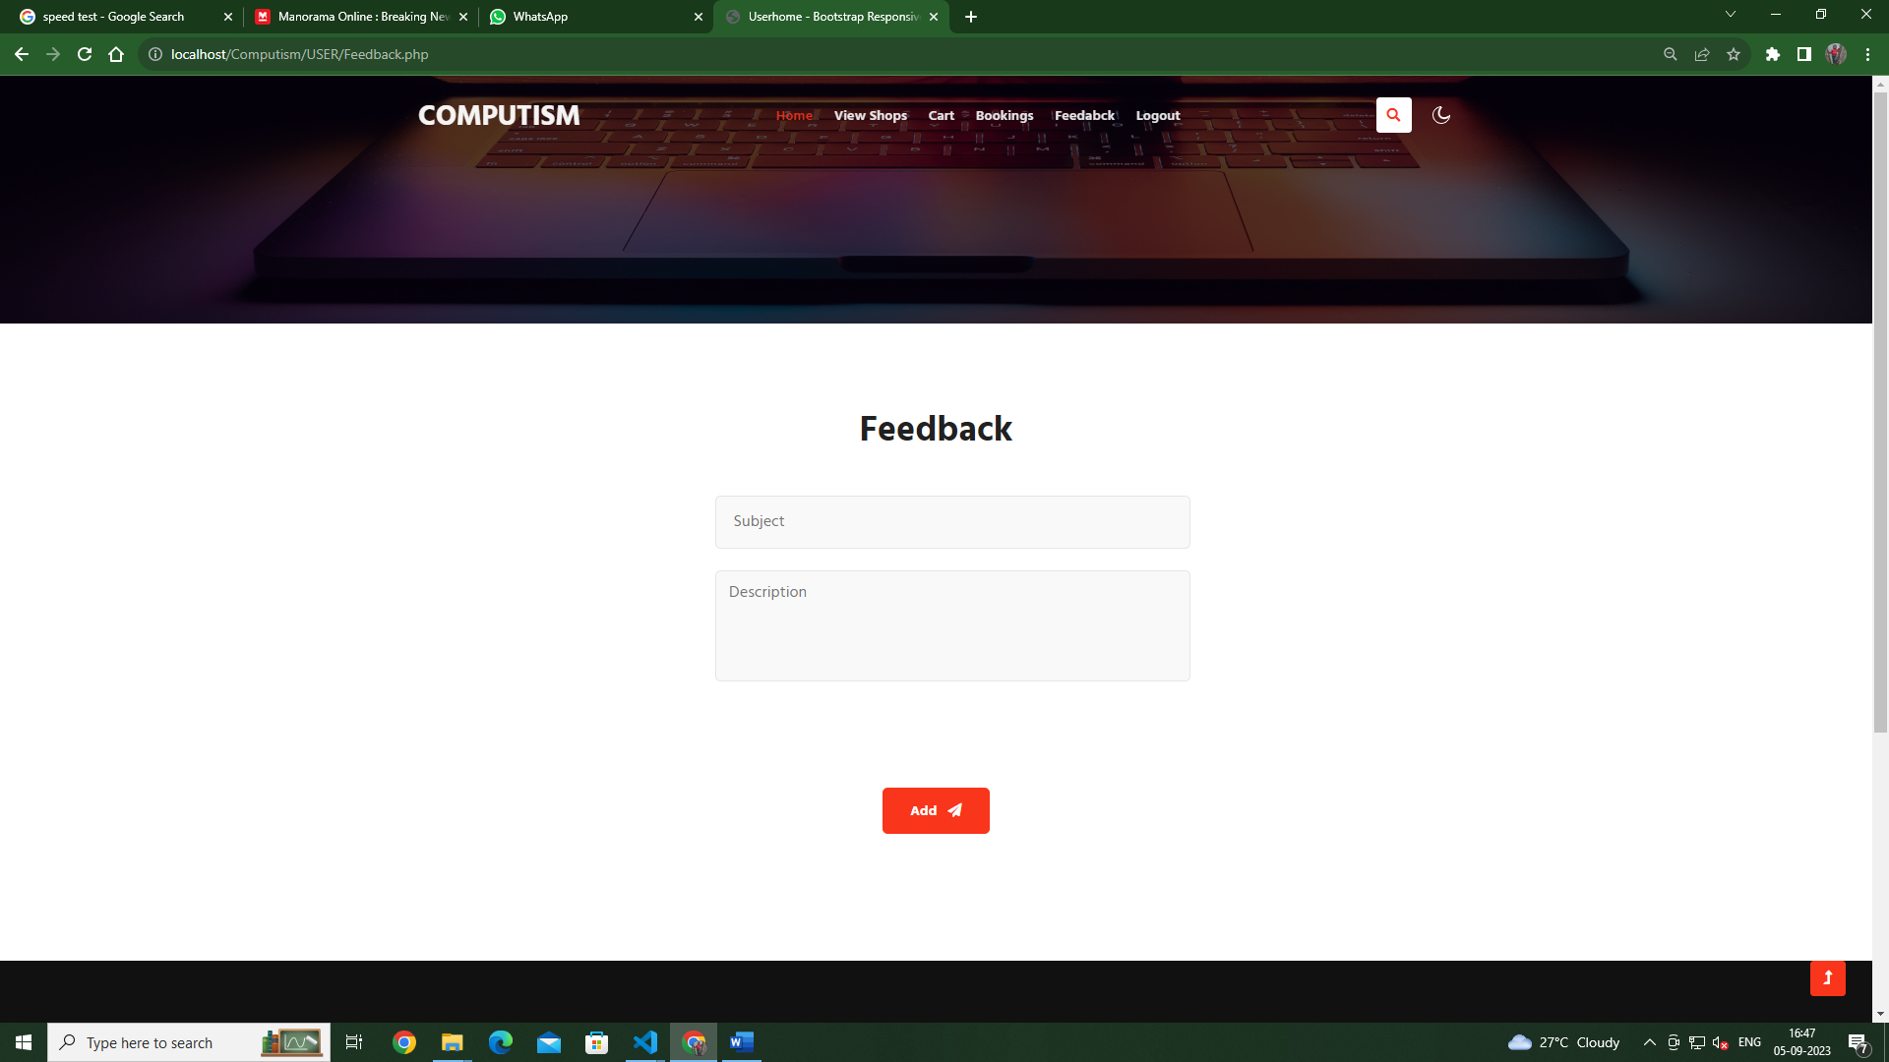

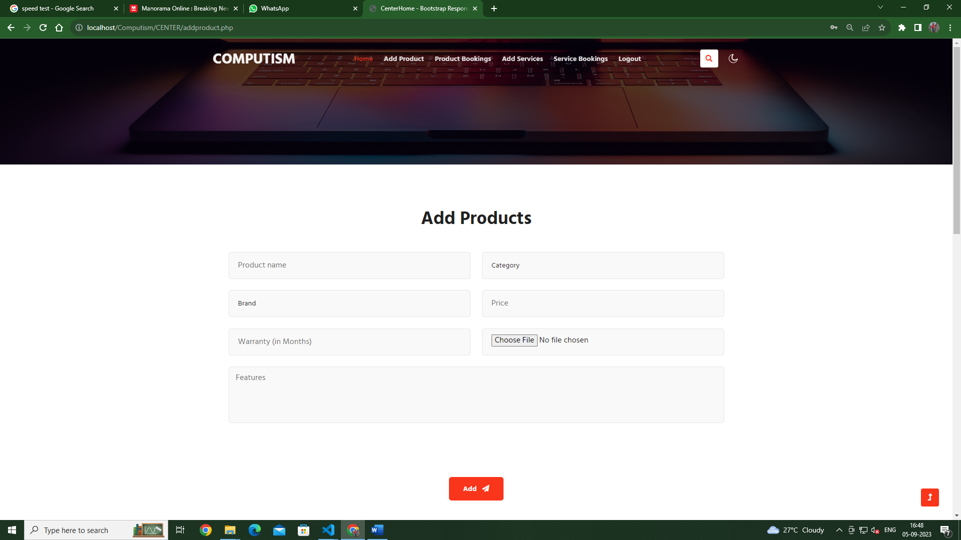

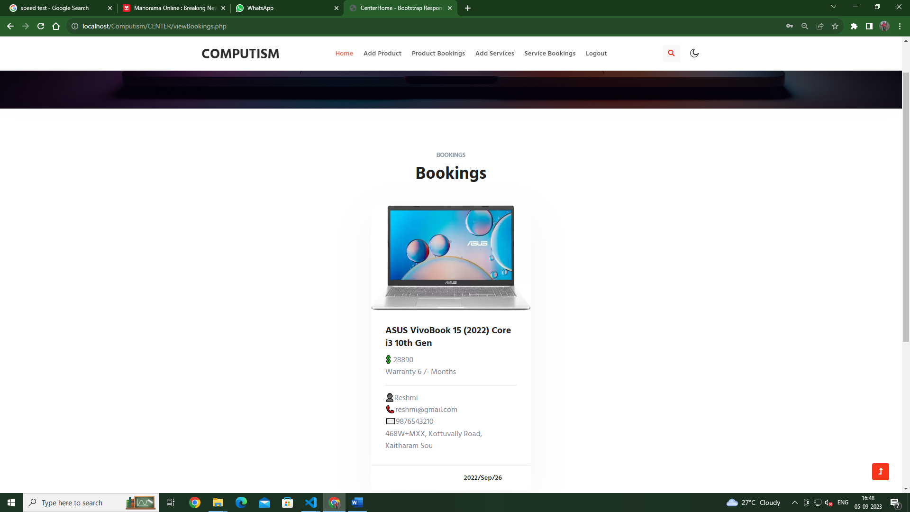

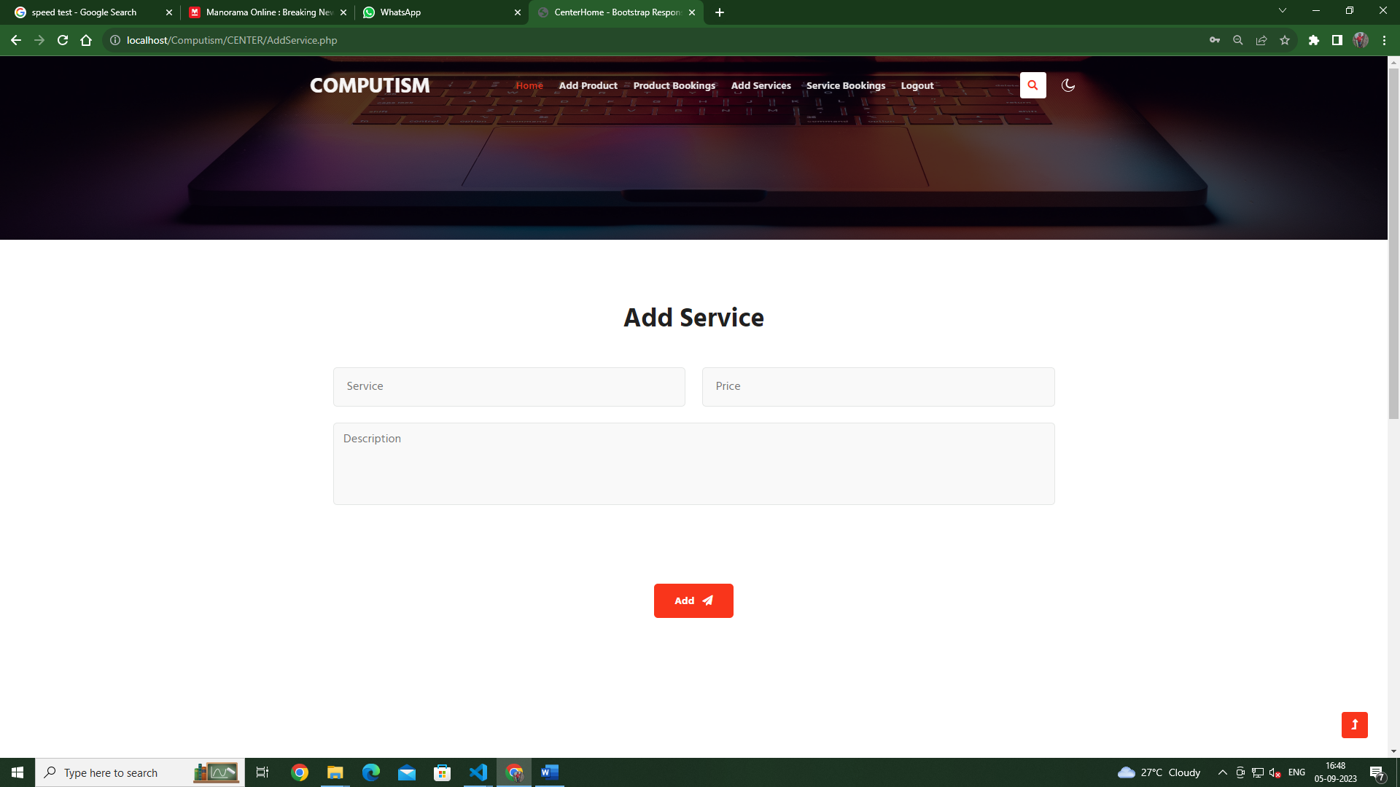

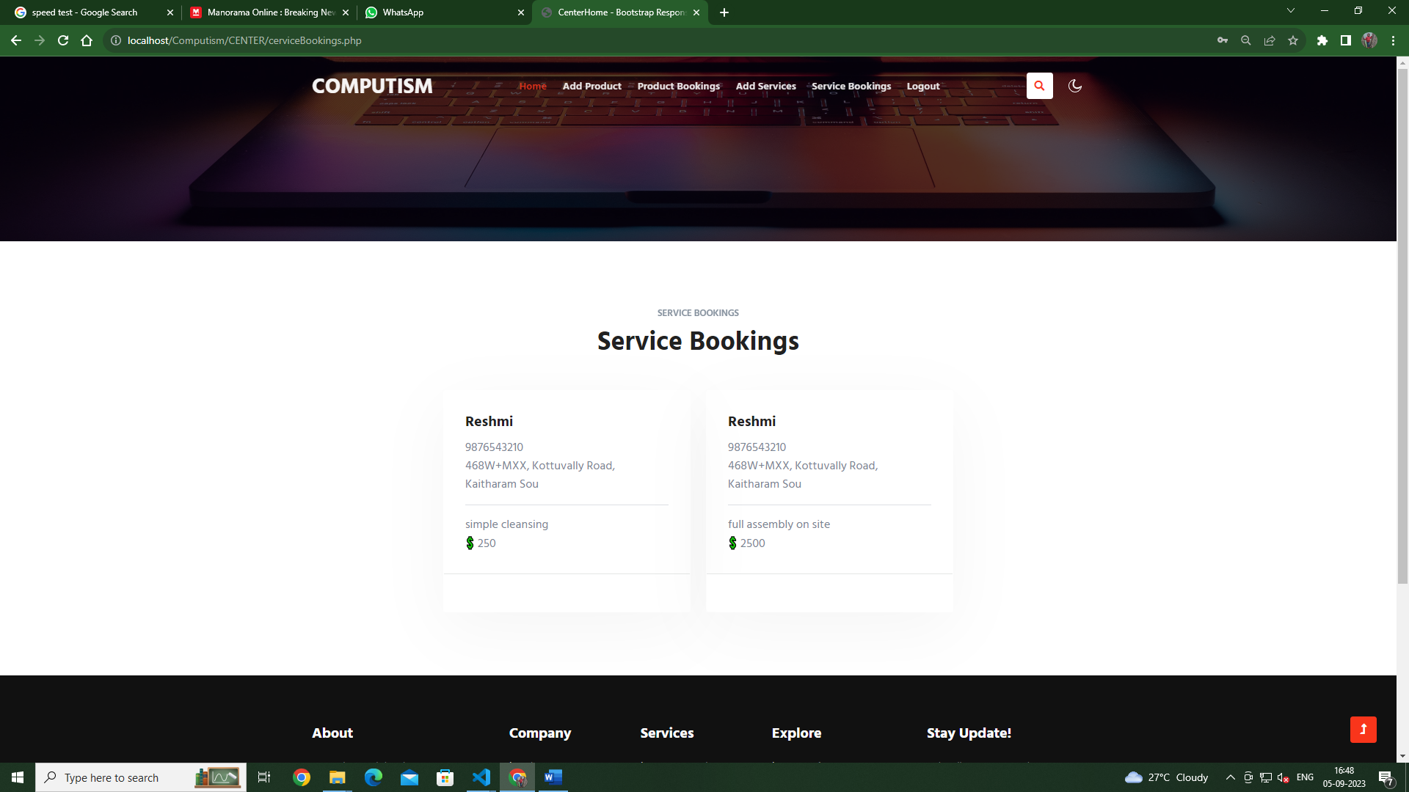

Tables

# Database computism

## Table structure for table brand

|  |  |
| --- | --- |
| **Field** | **Type** |
| ***brand_id*** | bigint(50) |
| Brandname | varchar(50) |

## Table structure for table category

|  |  |
| --- | --- |
| **Field** | **Type** |
| ***catid*** | bigint(50) |
| catname | varchar(50) |

## Table structure for table feedback

|  |  |
| --- | --- |
| **Field** | **Type** |
| ***f_id*** | int(10) |
| user_id | varchar(10) |
| subject | varchar(100) |
| description | varchar(100) |

## Table structure for table login

|  |  |
| --- | --- |
| **Field** | **Type** |
| ***l_id*** | int(20) |
| reg_id | varchar(50) |
| email | varchar(100) |
| password | varchar(100) |
| type | varchar(100) |
| status | varchar(100) |

## Table structure for table shop

|  |  |
| --- | --- |
| **Field** | **Type** |
| ***s_id*** | int(10) |
| sname | varchar(100) |
| sphone | varchar(100) |
| saddress | varchar(100) |
| semail | varchar(100) |
| photo | varchar(100) |

## Table structure for table tb_cart

|  |  |
| --- | --- |
| **Field** | **Type** |
| ***cart_id*** | int(100) |
| cusid | varchar(100) |
| centerid | varchar(100) |
| itemid | varchar(100) |
| item | varchar(100) |
| date | varchar(100) |
| status | varchar(10) |

## Table structure for table tb_product

|  |  |
| --- | --- |
| **Field** | **Type** |
| ***productcode*** | bigint(50) |
| centerid | int(100) |
| productname | varchar(50) |
| category | varchar(50) |
| brand | varchar(50) |
| price | bigint(100) |
| warranty | varchar(50) |
| features | varchar(500) |
| image | varchar(200) |

## Table structure for table tb_service

|  |  |
| --- | --- |
| **Field** | **Type** |
| ***servicebookid*** | int(122) |
| center_id | varchar(100) |
| servicename | varchar(100) |
| description | varchar(200) |
| fee | varchar(100) |

## Table structure for table tb_service_booking

|  |  |
| --- | --- |
| **Field** | **Type** |
| ***book_id*** | int(200) |
| centerid | varchar(200) |
| serviceid | varchar(100) |
| customer_id | varchar(100) |
| fee | varchar(100) |
| date | varchar(100) |
| status | varchar(200) |

## Table structure for table user

|  |  |
| --- | --- |
| **Field** | **Type** |
| ***uid*** | int(11) |
| uname | varchar(40) |
| uemail | varchar(40) |
| uaddress | varchar(40) |
| uphoneno | varchar(40) |

<?php

session_start();

include './COMMON/commonheader.php';

include './CONNECTION/DbConnection.php';

?>

<div class="w3l-contact-10 py-5" id="contact">

<div class="form-41-mian pt-lg-4 pt-md-3 pb-lg-4">

<div class="container">

<div class="heading text-center mx-auto">

<h5 class="title-subw3hny text-center"></h5>

<h3 class="title-w3l">User Registration <span class="inn-text"> </span></h3>

</div>

<div class="form-inner-cont mt-5">

<form method="post" class="signin-form" enctype="multipart/form-data">

<div class="form-grids">

<div class="form-input">

<input type="text" name="fname" id="w3lName" placeholder="Full name" required="" />

</div>

<div class="form-input">

<input type="text" name="phone" id="w3lSubject" placeholder="Phone " pattern="[789][0-9]{9}" maxlength="10" required />

</div>

<div class="form-input">

<input type="email" name="email" id="w3lSender" placeholder=" Email " required />

</div>

<div class="form-input">

<input type="password" name="password" id="w3lPhone" placeholder=" Password " required />

</div>

</div>

<div class="form-input">

<textarea name="address" id="w3lMessage" placeholder="Address" required=""></textarea>

</div>

<br><br><br><br>

<div class="w3-submit text-center">

<button type="submit" name="register" class="btn btn-style btn-primary">Register <i class="fas fa-paper-plane ms-2"></i></button>

</div>

</form>

</div>

</div>

</div>

<br><br><br><br><br>

<?php

include './COMMON/commonfooter.php';

?>

<?php

if (isset($_REQUEST['register'])) {

$Name = $_REQUEST['fname'];

$Phone = $_REQUEST['phone'];

$Address = $_REQUEST['address'];

$Email = $_REQUEST['email'];

$Password = $_REQUEST['password'];

$qryCheck = "SELECT COUNT(*) AS cnt FROM `user` WHERE `uemail` = '$Email' OR `uphoneno` = '$Phone'";

$qryOut = mysqli_query($conn, $qryCheck);

$fetchData = mysqli_fetch_array($qryOut);

if ($fetchData['cnt'] > 0) {

echo "<script>alert('Already exist an Account with same Email / Phone Number');window.location = 'UserRegistration.php';</script>";

} else {

$qryReg = "INSERT INTO `user`(`uname`,`uemail`,`uaddress`,`uphoneno`)VALUES('$Name','$Email','$Address','$Phone')";

$qryLog = "INSERT INTO login(`reg_id`, `email`, `password`, `type`,`status`) VALUES((select max(uid) from user), '$Email', '$Password', 'USER','approved')";

echo $qryReg . "&& " . $qryLog;

if ($conn->query($qryReg) == TRUE && $conn->query($qryLog) == TRUE) {

echo "<script>alert('Registration Success');window.location = 'login.php';</script>";

} else {

echo "<script>alert('Registration Failed');window.location = 'UserRegistration.php';</script>";

}

}

}

?>

<?php

$conn=mysqli_connect('localhost','root','','computism');

?> <?php

session_start();

include './COMMON/commonheader.php';

include './CONNECTION/DbConnection.php';

?>

<div class="w3l-contact-10 py-5" id="contact">

<div class="form-41-mian pt-lg-4 pt-md-3 pb-lg-4">

<div class="container">

<div class="heading text-center mx-auto">

<h5 class="title-subw3hny text-center"></h5>

<h3 class="title-w3l">User Registration <span class="inn-text"> </span></h3>

</div>

<div class="form-inner-cont mt-5">

<form method="post" class="signin-form" enctype="multipart/form-data">

<div class="form-grids">

<div class="form-input">

<input type="text" name="fname" id="w3lName" placeholder="Full name" required="" />

</div>

<div class="form-input">

<input type="text" name="phone" id="w3lSubject" placeholder="Phone " pattern="[789][0-9]{9}" maxlength="10" required />

</div>

<div class="form-input">

<input type="email" name="email" id="w3lSender" placeholder=" Email " required />

</div>

<div class="form-input">

<input type="password" name="password" id="w3lPhone" placeholder=" Password " required />

</div>

</div>

<div class="form-input">

<textarea name="address" id="w3lMessage" placeholder="Address" required=""></textarea>

</div>

<br><br><br><br>

<div class="w3-submit text-center">

<button type="submit" name="register" class="btn btn-style btn-primary">Register <i class="fas fa-paper-plane ms-2"></i></button>

</div>

</form>

</div>

</div>

</div>

<br><br><br><br><br>

<?php

include './COMMON/commonfooter.php';

?>

<?php

if (isset($_REQUEST['register'])) {

$Name = $_REQUEST['fname'];

$Phone = $_REQUEST['phone'];

$Address = $_REQUEST['address'];

$Email = $_REQUEST['email'];

$Password = $_REQUEST['password'];

$qryCheck = "SELECT COUNT(*) AS cnt FROM `user` WHERE `uemail` = '$Email' OR `uphoneno` = '$Phone'";

$qryOut = mysqli_query($conn, $qryCheck);

$fetchData = mysqli_fetch_array($qryOut);

if ($fetchData['cnt'] > 0) {

echo "<script>alert('Already exist an Account with same Email / Phone Number');window.location = 'UserRegistration.php';</script>";

} else {

$qryReg = "INSERT INTO `user`(`uname`,`uemail`,`uaddress`,`uphoneno`)VALUES('$Name','$Email','$Address','$Phone')";

$qryLog = "INSERT INTO login(`reg_id`, `email`, `password`, `type`,`status`) VALUES((select max(uid) from user), '$Email', '$Password', 'USER','approved')";

echo $qryReg . "&& " . $qryLog;

if ($conn->query($qryReg) == TRUE && $conn->query($qryLog) == TRUE) {

echo "<script>alert('Registration Success');window.location = 'login.php';</script>";

} else {

echo "<script>alert('Registration Failed');window.location = 'UserRegistration.php';</script>";

}

}

}

?>